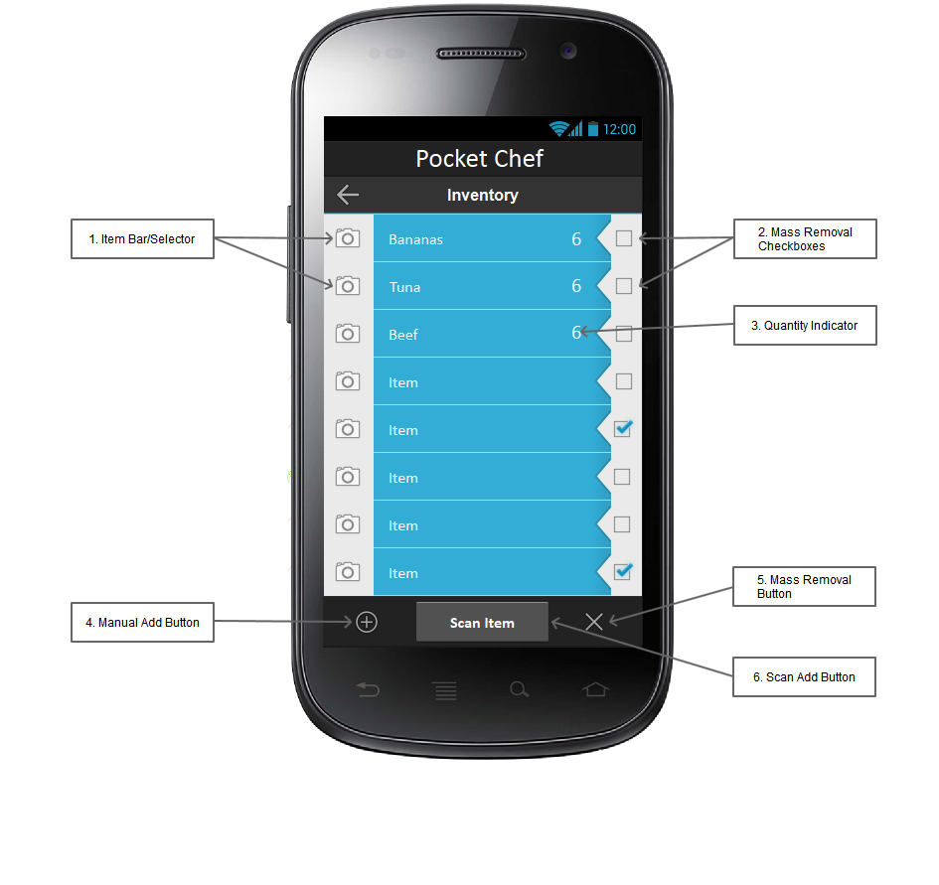
The PocketChef Inventory screen is one of three/four main screens. It allows a user to view the food items they have already added into the inventory. (1) Clicking on each item bar/selector will bring up a new page with information regarding that specific food item. The item bar/selector contains a thumbnail, item name, (3) the quantity of the item, and checkbox. (2) The mass removal checkbox is for easy disposal of a large number of already used food items. (5) The mass removal button can be pressed to delete all checked items. (4) The manual add button can be pressed to bring up a screen with a form to enter in details for a new food item. (6) The scan add button opens a page to allow a UPC scan to add items to the inventory.
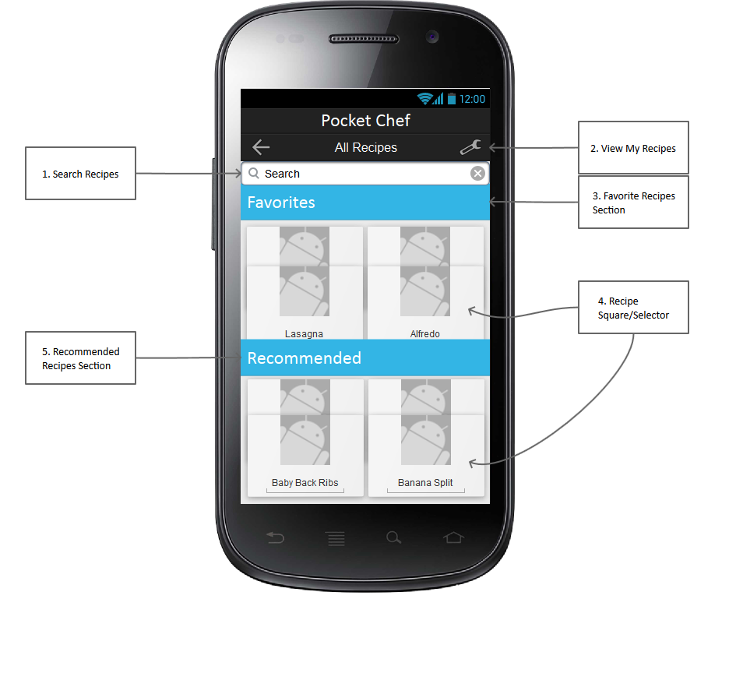
The PocketChef All Recipes page lets a user search for and view every current recipe in the database. (1) The search bar allows for various searches to narrow down the large recipe list into something more manageable. (2) If the view my recipes button is pressed, then the user will be taken to a screen to view and manage the recipes they have created themselves. (3) The favorite recipes section will contain a scrollable list of the recipes the current user has favorited. (4) The recipe square/selector contains minimal information about the recipe (thumbnail, name, type); however, if clicked it will serve as a link to a new page that contains the information about the specific recipe. (5) The recommended recipes section is going to show the user certain recipes based on either personal preference, or based on the current ingredients in their inventory.

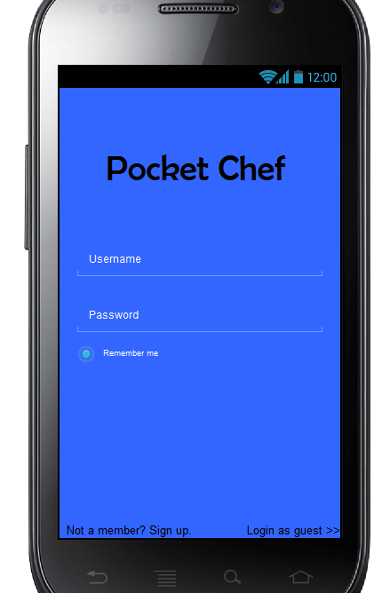
1. Title and logo
3. Password
6. Guest login
2. Username
4. Remember me
5. Register

This is the first screen a user will see upon opening the application. The top of the screen will contain the (1) title and, once we have designed a logo, a logo for the app. A little lower, the (2) username and (3) password slots are available for existing members to enter their credentials to access their information. Below the password slot there is a “remember me” checkbox (4) that allows an existing member to stay logged in. If they are not a member there is an option on the bottom left (5) that allows them to sign up and become a member and gain access to more features. If they do not want to become a member then they may login as a guest (6) and use the app but with limitations.

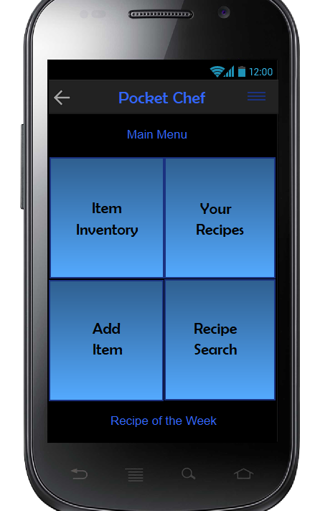
2. Main menu logo
3. Item Inventory
5. Add Item
4. Your recipes
Recipe of the week
6. Recipe Search
1. Side menu

This is the main menu screen. This is the first screen the user will see upon opening up the app or logging on. At the top right of the page there is a (1) side menu that will give the user more specific options like settings. At the top there is just a logo that says Main Menu (2). Next we have four square buttons in the middle of the screen. The first (3) is the Item Inventory. This button will take you to the user’s inventory of food items. Second we have the (4) Your Recipes button. This will like the user to their created recipes they have submitted. Third there is the (5) Add Item. This will take the user to a page that will give them the option to either scan an item or manually enter it into their inventory. Lastly there is a (6) Recipe Search page that will have the capability to search through the complete list of recipes submitted to the app. At the bottom of the page we will have some sort of option for the user to view the (7) recipe of the week based on ratings.

